**Acknowledgment**

Very special thanks to Prof. Dr**. Eid Abdel-Hakem** who teaches us and encourage us to work. Without his grace this project could not complete.

I would like to express my special deep gratitude to my Teaching Assistant **Sara Silliman** who gave us the golden opportunity to do this project and for guidance and support us in completing this project.

Also, TA/ Sara helped us in doing a lot of work and we came to know about so many new things, we are really thankful to her.

Finally, we thank her for sharing her views and sparing her valuable time for us.

**Key Terms**

|  |  |
| --- | --- |
| UAVs | Unmanned Aerial Vehicles |
| UASs | Unmanned aircraft systems |
| ESC | Electronic Speed Controller |
| PWM | Pulse Width Modulation |
| SRAM | Static Random-Access Memory |
| Yaw | Rotation about z-axis |
| FC | Flight controller |
| GCS | Ground control system |
| VTX | Video transmitter |
| TX | Radio transmitter |
| RX | Radio receiver |
| OSD | On screen display |

**Table of Contents**

**Part 1: Introduction to drone system**

- What can drones do……………………………………………….…………………………………….... 7

- Drone Parts Overview ……………………………………………………………………………………………. 8

# Part 2: Requirement Specifications

- User requirement for target dedication ………………………….……….…………………………. 14

- System requirement for target dedication ………………………………………………………….. 15

- User requirement for flight controller ………………………….……………………….…………… 18

- System requirement for

Flight controller ……………………………………………………………………………………………… 19

# Part 3: Functional and nonfunctional requirements

- Functional requirement …………………………………………………….…………………..... 20

- Nonfunctional requirement …………………………………………………….……………….. 20

- Software System Attributes………………………………………………………………………… 21

- Hardware Constraints……………….………………………………………………….…………… 23

- Performance Constraints …………………………………………………………………………… 25

- External requirements ……………………………………………………………………………… 26

# Part 4: System models

- Context model…………………………………………………………………….…………………………………….. 29

- Use case mode for drone………………………………………………………………………………………………. 30

- Sequence diagram for drone ……………….……………………….……………………………………………… 31

- Use case model for Flight Controller ………………………………………………………………………..…… 32

- Sequence diagram for Flight Controller ………………………………...……………………………………… 33

- Activity model …………………………………………………………………..…..…………………………………….34

**Table of Figures**

**Introduction to drone system**…………………………................................................................................................

Figure1.1 Drone shape......................................................................................................................................7

Figure1.2 Drone

Parts......................................................................................................................................8

Figure1.3 Drone brushless motors………………………………………………………………………………………………………………....9

Figure1.4 Drone flight controller…………………………………………………………………………………………………………….11

**Requirement Specifications** ……………………………………………………………….

Figure2.1 Drone Communication.....................................................................................................................15

Figure2.2 Target identification………………….................................................................................................17

**System models** ………………………………………………………………………….

Figure4.1 Context model..........................................................................................................................................29

Figure4.2 Use case model for target dedication…………………...................................................................................30

Figure4.3 Sequence diagram for target dedication……………......................................................................................................................31

Figure4.4 Use case model for Flight Controller…………………....................................................................................32

Figure4.5 Sequence diagram for Flight Controller……...............................................................................................................34

Figure4.6 Activity model …….......................................................................................................34

**References**

* <https://online.visual-paradigm.com>
* <https://creately.com>
* <http://www.ijert.com>
* <https://nppa.org/magazine/drone-code-ethics>

**Introduction to drone system:**

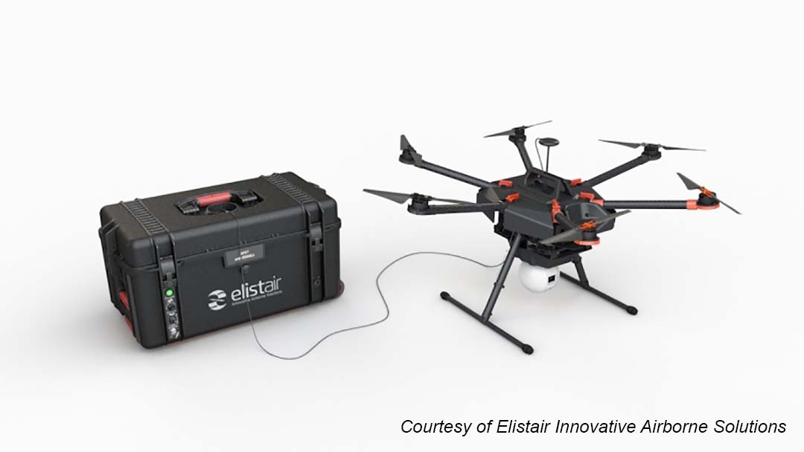A drone, in technological terms, is an unmanned aircraft. Drones are more formally known as unmanned aerial vehicles (UAVs) or unmanned aircraft systems (UASes). Essentially, a drone is a flying robot that can be remotely controlled or fly autonomously through software-controlled flight plans in their embedded systems, working in conjunction with figure1.1 onboard sensors and GPS.

What can drones do?   
To the military, they are UAVs (Unmanned Aerial Vehicles) or RPAS (Remotely Piloted Aerial Systems). However, they are more commonly known as **drones**.

**Drones** are used in situations where manned flight is considered too risky or difficult. They provide troops with a 24-hour "eye in the sky", seven days a week.

Quick Drone Parts Overview

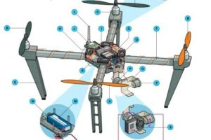

Figure1.2

**A. Standard Prop**

The “tractor” propeller are the props at the front of the quadcopter.  These props pull the quadcopter through the air like a tractor.  While some drones like the DJI Phantom look more or less the same from any angle, there is a front and back.

Most drone propellers are made of plastic and the better quality made of carbon fiber.  For safety, you can also add drone prop guards which you need especially if you are flying indoors or near people.

Propeller design is an area where there is plenty of new innovation.  Better prop design will assist in a smoother flying experience and longer flight times. There is also some big innovation towards [low noise uav props](http://www.nwuav.com/uav-products/low-noise-propellers.html).

### B. Pusher Prop

The Pusher props are at the back and push the UAV forward hence the name “Pusher props”. These contra-rotating props exactly cancel out motor torques during stationary level flight. Opposite pitch gives downdraft.  These can be made of plastic with the better pusher props made from carbon fiber.  You can also purchase guards for the pusher props.

C. Brushless Motors

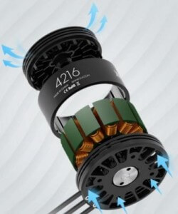

Figure1.3

Practically all the latest drones use a brushless electric “out-runner” type, which is more efficient, more reliable, and quieter than a brushed motor.  Motor design is important.  More efficient motors save battery life and give the owner more flying time, which is what every pilot wants.

Drone motor design is pretty exciting at the moment. The top of the range [DJI Inspire 1](https://www.dronezon.com/drone-reviews/dji-inspire-1-review-with-youtube-videos/) released earlier this year are a new patented design.  DJI developed and patented a new curved magnet which fits perfectly around the motor allowing the motor to run more efficiently.

D. Motor Mount

The drone motor mount is sometimes built into the combination fittings with landing struts or can be part of the UAV frame. There are quite a few parts which are easy to replace on most drones. Watch how easy it is to replace the [Parrot AR motor here](https://youtu.be/xVH2djmAAOc).  You will also notice that the motor mount is part of the central cross of the Parrot AR.

### E. Landing Gear

Drones, which need high ground clearance may adopt helicopter style skids mounted directly to the body, while other drones which have no hanging payload may omit landing gear altogether.

Many fixed wing drones which cover large distances such as the SenseFly eBee, Trimble UX5 or the 3DR Aero-M don’t have landing gear and land perfectly fine on their belly.

Most drone has a fixed landing gear. However, the best drones will have retractable landing gear giving a full 360 degree view when in the air.

### F. Boom

Shorter booms increase maneuverability, while longer booms increase stability. Booms must be tough to hold up in a crash, while interfering with prop downdraft as little as possible.  In many drones, the boom is part of the main body. Other drone have a definite boom as a separate part. The Parrot AR 2.0 has the central cross boom.

### G. Main Drone Body Part

This is the central hub from which booms radiate like spokes on a wheel.  It houses battery, main boards, processors avionics, cameras, and sensors.

### ****H. Electronic Speed Controllers (ESC)****

An electronic speed controller or ESC is an electronic circuit with the purpose to vary an electric motor’s speed, its direction and possibly also to act as a dynamic brake. It converts DC battery power into 3-phase AC for driving brushless motors.

Electronic Speed Controllers are an essential component of modern quadcopters (and all multirotors) which offer high power, high frequency, high resolution 3-phase AC power to the motors in an extremely compact miniature package.

A massive leap in ESC innovation came on the DJI Inspire 1, which uses new [sinusoidal](https://en.wikipedia.org/wiki/Sine_wave) drive electronic speed controllers to replace the more square wave drive of traditional ESCs.  The Inspire 1 goes further by using [closed loop torque control](https://en.wikipedia.org/wiki/Direct_torque_control)and distinct functional redundancy, which adds extra efficiency and reliability to the motors.

### ****I. Flight Controller****

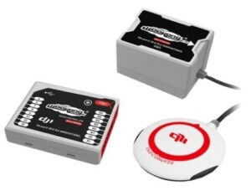

Figure1.4

The [flight controller](https://www.dronezon.com/learn-about-drones-quadcopters/three-and-six-axis-gyro-stabilized-drones/) interprets input from receiver, GPS module, battery monitor, IMU and other onboard sensors. It regulates motor speeds, via ESCs, to provide steering, as well as triggering cameras or other payloads. It controls autopilot, waypoints, [follow me](https://www.dronezon.com/drone-reviews/best-follow-me-gps-mode-drone-technology-reviewed/), failsafe and many other autonomous functions.  The flight controller is central to the whole functioning of your UAV.

### J. GPS Module

The GPS module often combines GPS receiver and magnetometer to provide latitude, longitude, elevation, and compass heading from a single device. GPS is an important requirement for [waypoint navigation](https://www.dronezon.com/learn-about-drones-quadcopters/drone-waypoint-gps-navigation-technology-explained/) and many other autonomous flight modes. Without GPS, drones would have very limited uses.

Along with FPV, drones can navigate long distances and be used for exciting applications such as creating 3D images using [lidar](https://www.dronezon.com/learn-about-drones-quadcopters/uav-lidar-applications-services-technology-systems/) and [photogrammetry](https://www.dronezon.com/learn-about-drones-quadcopters/introduction-to-uav-photogrammetry-and-lidar-mapping-basics/) sensors.

GPS stands for Global Positioning System. It is an American standard which provides location and time information in all weather conditions, anywhere on or near the Earth where there is an unobstructed line of sight to four or more GPS satellites.

Some of the latest drones have added Glonass, which is the Russian equivalent of GPS.  This means your drone is almost guaranteed to find many more satellites to get its positioning from.  With both systems, you can fly more accurately and also can fly safer as you know you won’t loose satellite connection.

**Tip:** Most drones allow you to program in a failsafe home point.  This allows the drone to fly back to a point if it loses connection to your remote controller.  Most drones have a minimum requirement of satellites before the home point  can be set.  But always set a home point. When buying a drone, keep an eye out for drones which come with both GPS and Glonass.

### ****K. Receiver****

Often a standard r/c radio receiver unit. The minimum number of channels needed to control a quad is 4, but 5 is usually recommended. There are many manufacturers of receivers on the market if you are building your own drone.

### L. Antenna

Depending on your receiver, it may be a loose wire whip or helical “rubber ducky” type.

### M. Battery

Lithium polymer (LiPo) batteries offer the best combination of energy density, power density, and lifetime on the market.

### N. Battery Monitor

Provides in-flight power level monitoring to flight controller. Your battery is critical to flying safely. If you fly too far out and your quadcopter runs out of battery then it will either make an emergency landing or will crash.

### ****S. Sensors****

Drone are more than just for aerial filming and photography.  We are now seeing lidar, thermal and many other types of sensors being mounted onto drones and being used in a wide variety of sectors.

The mounted camera along with the GPS can be used to create accurate 3D photogrammetry images.

3D mapping, also known as photogrammetry mapping is the science of making measurements from photographs. The output from photogrammetry software is typically a 3D map, a 3D drawing or a 3D model of some real world object or land mass.

By flying a mapped route and taking photos at regular intervals of say every 1 second, these images are then stitched together to create 3D photogrammetry images.

To create 3D maps or models, all you need is a [top drone with camera and GPS](https://www.dronezon.com/drone-reviews/drone-gps-autopilot-at-very-affordable-prices/). The drone will capture the images and any of these [top photogrammetry software](https://www.dronezon.com/learn-about-drones-quadcopters/drone-3d-mapping-photogrammetry-software-for-survey-gis-models/) applications will stitch the photos into 3D maps or models.

### ****T. Collision Avoidance Sensors****

Drones today can come with 2 types of sensors.  The above for creating 3D images of the external world by using Lidar and [Thermal vision cameras](https://www.dronezon.com/learn-about-drones-quadcopters/9-heat-vision-cameras-for-drones-and-how-thermal-imaging-works/). The 2nd type is on-board [sensors for collision avoidance](https://www.dronezon.com/learn-about-drones-quadcopters/top-drones-with-obstacle-detection-collision-avoidance-sensors-explained/) using Monocular Vision, Ultrasonic (Sonar), Infrared, lidar, Time-of-Flight (ToF) and Vision Sensors.

That covers the vast majority of components you will find in your modern day drone.

In this system we use Mission-critical systems

Mission-critical systems A system whose failure may result in the failure of some goal-directed activity.

# Requirement Specifications

1- User Requirement

The drone, a quad chopper, will be very useful in search and recovery operations, especially in remote areas or in extreme weather conditions. It will click high-resolution images. It will fly according to a path preset by a ground operator, but will be able to avoid obstacles on its own, returning to its original path whenever possible. The drone will also be able to identify various objects and match them to the target it is looking for.

2-System Requirement

|  |  |
| --- | --- |
| Function: | Searching and dedicating target. |
| Description: | This is main part of this project. The SURF algorithm is used to identify the particular object and then the background will be subtracted to follow the identified object. |
| Inputs: | The color and the size of the target or object. |
| Source: | Storage memory. |
| Output: | Dedicated target location drone height. |
| Destination: | Ground controlling unit. |
| Action: | Figure2.1  Serial communication will be initialized to start the communication between camera and the computer. After the initialization the camera starts to search for the defined target in the environment. There are two options. It may detect the object or may not detect. If it detects the defined object the target information will be collected and then transmitted to ground control system or GCS to calculate the center point of the target.  The information is then used to calculate the target position/ X, Y coordinates altitude and time.  The information of the object will be displayed in the system monitor. If the target is not found then the UAV starts to search the target again. If the target is missing for a long time the UAV will come back to its starting position. Ultrasonic sensor used to collect the data about the target and the Wi-Fi is used to transmit the data to the ground control system GCS.  IMAGE PROCESSING: - Two tasks are given to the processor to complete this project. First one is ground motion estimation and second task is target detection and tracking. Depending on imaged scene both tasks leads to many problems. In order to avoid this target identification and tracking is made simpler by assuming the color and the size of the target or object. And the tests are conducted in daytime. The target standard specification parameters are stored in the beginning of the source code. This allows ease in changing the parameters to cater for different mission which may require targeting of different vehicle. This paper used the source code which has the flexibility of changing the camera and its parameters.  When capturing the video simultaneously the coding will change the original images into grayscale image. First window shows the original image from the video camera and the second window demonstrate the image which is processed from the original video. Information about the UAV is updated by the microplot. It collects height and heading of the UAV. Target information is sent to GCS only when the target is found. Speeded Up Robust Feature, SURF is used for feature detection and back round subtraction. It will extract some unique key points and descriptors from an image. These extracted points will be saved and used later.  ¬ Detection ¬ Description ¬ Matching.  After getting successful result from ground test the actual flight test was done to conform the working of the source code. The value of tested color was set in the calibrating panel and then the test was continued.  HSV means hue, saturation and value color space. V is also can be represent as brightness. HSV models are often used in image analysis feature detection or image segmentation. This application tools had been used here and got great results. By changing these values we can define all the colors and then we can track the required object.  When multiple possible targets being encountered the target which is to be tracked can be selected by changing the object id. The color intensity values will be changing from zero to 255.  EXPERIMENTAL RESULT :-  In order to test the designed target identification system, a ground test is conducted. Preliminary test is color matching and the next one is vehicle detection. The below images are the results got from the ground test. The small size of car with 10cm by 10cm is used as a target to get the experimental result. When this test is conducted the UAV were in the ground. After getting positive results altitude of the UVA was changed and tested again.  Color detection with background subtraction    Figure2.2  From figure 1 it’s clearly understood that the target identification system works properly. Pictures a and b are the examples of background subtraction in color based target detection and tracking and figure c gives the result without background subtraction. Image d is the multiple target identification. If multiple targets are being encountered at the same time the coding will choose the mean point of the possible targets as its tracking point. The final tests were carried out for checking data transmission and found a good result. Ground test was conducted for all type of vehicle from small to large sizes and verified successfully. |
| Requires: | Storage memory to store all the targets info we ganna match with a data communication link between the UAV(drone)and the ground control system GCS. |
| Preconditions: | Available target information to dedicate it with objects a presented path. |
| Post condition: | New targets informations are setted to the storage memory to be used by the UAV. |
| Side Effect: | None. |

1- User Requirement

The flight controller (aka “FC”) is the brain of a quad copter, it has sensors on the board so it can understand how the craft is moving. Using the data provided by these sensors, the FC uses algorithms to calculate how fast each motor should be spinning for the craft to behave as the pilot is instructing via stick inputs on the TX (Radio Transmitter). Most of the wiring on your quad will be focused around the FC. It needs to have the RX (receiver) connected, so it can be told what the pilot wants the craft to do. Each of the ESC signal and ground wires need to be connected for the FC commands to be carried out by the motors. With the introduction of BetaFlight OSD (On Screen Display), even the video feed from the FPV camera goes via the FC to the VTX (Video Transmitter).

2-System Requirement

|  |  |
| --- | --- |
| Function: | Flight Controller. |
| Description | How the craft fly. |
| Inputs: | Instructions via stick. |
| Source: | Ground operator. |
| Output: | Craft moving. |
| Destination: | Moving on a specific path & OSD |
| Action: | The FC has sensors to understand how the craft is moving.  The pilot is instructing via stick inputs so, he can control the quad copter speed. If the battery of the stick is empty charge, then the pilot can recharge it or change the battery with new one. When the RX (receiver) is connected, the pilot can control everything and told the craft what to do. If the connection interrupts between the pilot and the craft, then it should reconnect it with the pilot. If the connection still missing for a long period, then the craft should go back to start point. |
| Requires: | It needs the RX (receiver) to be connected, so it can be told what the ground operator wants the craft to do. Also, ESC signals and ground wires need to be connected. |
| Preconditions: | Sensors are on to understand what the controller should do and the ground wires are available to connect the controller with the pilot. |
| Post condition: | Air craft returns to start point. |
| Side Effect: | It may enter a restricted area. |

**Functional Requirement**

* Target Dedication.
* Air Craft Control.

**Nonfunctional requirement**

Constraints on the services or functions offered by the system such as timing constraints, constraints on the development process, standards etc.

Often apply to the system as a whole rather than individual features or services.

Performance is vital in projects that require real time computations and that contain hardware components. This statement is also true for our project. Since our project is subdivided in 3 parts which are interrelated and will work simultaneously, a high level of performance is expected from the 3 parts, especially the MATLAB application which will send commands to the Arduino microcontroller and to the simulation. This is the reason that we chose MATLAB as our platform for

Implementing motion planning algorithms, since MATLAB applications are high performance especially in making calculations of big data, such as three-dimensional matrices. A critical aspect of our project is the algorithm that will allow the quadcopter to hover in space without losing its balance. This algorithm will run on the Arduino microcontroller and it will be processing data received from the sensors located on the quadcopter and fetching the rotation speed of the motors through the ESCs. Thus, the performance of this algorithm is quite essential, since a small delay may cause the quadcopter to quickly lose its balance, fall over and may result in material damage as well as put the nearby human lives in danger.

**Software System Attributes**

**Reliability**

Our system is mostly depending on hardware. We are doing sensor data processing and communications between different hardware components. As a result the reliability of our project highly depends on the reliability of the singular hardware components and their interfaces. These hardware reliability requirements are:

• Sensor data has to be true at least 99.9% of the time

• Data must get from the sensor at most 0.1 second.

• Communication between hardware has to be true at least 99% of the time.

• Communication must be done at most 0.3 second.

**Usability**

Our target customers mostly include researchers and security agencies, but we will still create a simple enough interface for ages greater than 13.

This interface will comply with design interface standards that make the user's interaction as simple and efficient as possible.

**Portability**

Since we will develop both a simulation and a MATLAB application that will receive environment data, and send motion commands to a real quadrotor, the portability of our project in general is not well founded. The simulation will be created in Unity 3D, so we will be able to port the simulation as a standalone application in different platforms. But the project as a whole will not be well-portable. Especially since the changing the working environment of the real quadrotor is not feasible, as the working environment of our project as of now is a high-tech specialized laboratory in the MODSIMMER Research Center. This aspect of portability may be later resolved by adding advanced sensors that may take information about the environment.

**Maintainability**

The simulation part will be easily maintainable. Whereas the quadcopter’s maintainability is a little harder to accomplish, since it contains delicate parts and may be subject to damage if comes into contact with other objects. The battery’s life is another concern, since the battery life of a LiPo battery lasts approximately 1 year.

**Safety**

Working with embedded hardware and electrical parts, batteries etc. always contains risks. In addition, the quadcopter’s rotating blades contain life risks, since if they are detached from the rotors, they may fly in unpredicted directions and endanger people’s lives. As a result, we will conduct extensive testing before finalizing our product so that such risks are decreased at a minimal level. We will also set a minimal age for the users of our product.

**Security**

Since our project will not deal with sensitive private data, security is not a real concern. The only matter of interest in the security perspective is the data handled by the Xbee wireless communicators. But since the Xbees encrypt the data that they send/receive, no intruder may interfere with our data.

* Speed: the sensor will determine the current speed of the drone.
* Checkpoint detection: detection of at least 90% of check point markers.
* A tutorial will be written to make it easy for use to the average Joe.
* The AR Drone path could be set in any open space (minimal obstacles) fast.
* The code documentation will be written as clear and detailed as possible

**Hardware Constraints:**

The design can act as a UAV as well as drone. It has USB and Wi-Fi (802.11n) interfaces. The onboard sensors are made more sensitive for better control. The ultrasound altimeter is enhanced with the addition of an air pressure sensor, allowing for more stable flight and hovering.

ARM CORTEX processor is used. It is designed with the customized flight control system. FCS consists of accelerometer gyro and magnetometer. Three axis gyros are used to get stability.

Calibrated compass is used to indicate the direction. It can achieve maximum of 165ft altitude. And the endurance is 20-30mins. Lithium ion battery is used to give the power to the UAV.

Inertial measuring unit is used for the orientation purpose. It is designed with twin cameras for safer side.

Cameras are mounted in front of the UAV which is front camera and another one is a vertical camera mounted downwards.

Front camera 720p sensor with 93° lens, recording up to 30fps.

Vertical camera: QVGA sensor with 64° lens, recording up to 60fps

There are several design constraints to our project. These constraints result from the nature of our project, which embodies different science and engineering disciplines, such as the physical science, electrical and electronic engineering, computer engineering and mechanical engineering. In this subsection we will review such constraints that may limit the functionalities of our final product.

• When trying to control the quadrotor, we should strictly calculate the center of mass of the quadrotor. So, when adding new parts on the quadrotor or changing a component we should recalculate the center of mass.

• The Arduino has a limited memory of 32 KB, so we should be careful when processing the sensor data so that we don’t fill all the memory up.

• When applying motion planning algorithms to the quadrotor, the quadrotor’s environment should be known. This limits our ability to test the quadrotor in unknown environments.

• We used a li-po battery to power up our quadrotor. This battery lasts for 15 min, and it requires 3 hours to be fully recharged. This limits our ability to design algorithms that last longer.

• The quadrotor must remain inside a perimeter with radius 30 m from the laptop/computer that runs the MATLAB application that is connected to the quadrotor. The reason is that the Xbee wireless transmitters have a range of 30 m.

• Unity 3D will be used to run the simulation

• MATLAB will be used to run motion planning algorithms and send commands to the Arduino microcontroller and to the simulation

• Arduino SDK will be used to program the Arduino UNO microcontroller

# Performance constraints:

Lighting and visibility conditions: the environment must be well lit and there must not be anything that might hurt visibility. Specific values TBD.

Battery: according to manufacturer the drone battery can last 12 minutes of flight.

Reliability: the system is not expected to handle any kind of failure except landing the drone safely in case of emergency.

Usability: the system is expected to be very usable with almost no training.

Anyone should be able to lay down navigation markers and just start the Program

* The system is not interactive. All input comes from camera/sensors built-in.
* The drone and to which we have full access.
* We will not use any simulations; we will operate the actual drone.
* The hardware required is the A.R Drone it-self and a PC with Wi-Fi.
* Development will take place at home and at the university laboratories.
* The final presentation (as the testing) will be performed by marking a path and letting the drone fly along it.

# External requirements:

Drone Journalism Code of Ethics Drone journalists should adhere to federal, state and local laws with safety concerns and the ethical decision-making embodied in the codes of ethics adopted by the National Press Photographers Association, the Society of Professional Journalists and the Radio and Television Digital News Association. Drone-journalism ethics should be even more stringent than other journalism ethics. It is one form of journalism legally regulated by government authorities that control airspace. Consider these guidelines: Safety is the first concern. Do not endanger people, animals or property. Drone pilots operating as commercial operators have an obligation to seek their FAA Part 107 license. The pilot should obtain adequate insurance coverage for property damage and injury that could result from drone flights. Journalists generating content for their newsroom should not claim they are recreational pilots to avoid licensure requirements. Newsrooms should not encourage others to fly illegally. Newsrooms should discourage drone flights that violate FAA regulations by declining to publish, broadcast or post still images or video that, although legally obtained by the news organization from a third party, may contain evidence of those violations (i.e. flights over people, night flights). Not rewarding unauthorized drone use with public recognition may help to discourage similar violations by others. If the images or video captured through improper means are of such high news value that the journalists deem them newsworthy, the journalist or news organization should clearly explain why those images are newsworthy despite the techniques utilized to capture them. Would you “do that” if you were capturing the image while on the ground? If you would not peer over a fence, look into a window or enter private property, how would you justify capturing the same image because you are airborne? Respect privacy. The Society of Professional Journalists code of ethics says, “Balance the public’s need for information against potential harm or discomfort. The pursuit of the news is not a license for arrogance or undue intrusiveness.” What is your journalist purpose? How is this tool helping you to tell a more complete story? Respect the integrity of the photographic moment. Drones have the potential to interrupt events, especially when hovering low. While photographing subjects, drone journalists should not intentionally contribute to, alter, or seek to alter or influence events. Do not improperly enhance. Music has the potential to set an editorial tone. How does that editorial tone affect the truth you are conveying? Journalists should not add natural sound to drone video unless the sound was captured at the same time and place as the drone video was captured. Carefully consider how slow motion or speeding up effects might affect the editorial integrity of the video. Slow motion can appear dramatic and change the context of a news story. Video sped up may add false urgency. Newsrooms should recognize that the pilot in command makes the decision about whether a flight can be accomplished safely. Newsrooms should not ask or pressure a drone pilot to fly in a way that the pilot in command considers to be unsafe or legally questionable. Drone-journalism pilots in command should not be expected to report or perform other duties while commanding an aircraft. Safe drone flight should be the pilot’s main concern while operating a drone or overseeing performing preflight checks. Drone journalists have an obligation to hone their flight skills and “stay sharp.” Practice flying in various atmospheric conditions. FAA sectional maps change, and the FAA is constantly updating flight and airspace restrictions. Pilots should stay current on changes to the evolving legal landscape regarding drone operations. Drone journalists have an obligation to be certain their aircraft and gear are in good repair. Preflight and post-flight safety-inspection checks are a must. Pilots should inspect props, motors, batteries and the aircraft body. Do not allow cost-cutting to compromise safe flight. If you cannot afford to fly safely, you cannot afford to fly. Coach others. The public’s perception of drone flights depends on how professionally pilots operate in these early days of this emerging technology. If the public sees drone needlessly invading privacy and putting people at risk, there is no doubt voters will pressure public officials to clamp down on drone operations. It is in your interest and the public’s interest for you to coach other operators, especially other journalists, when you see them flying unsafely, illegally or unethically.

<https://nppa.org/magazine/drone-code-ethics>

# System models

## Context model:

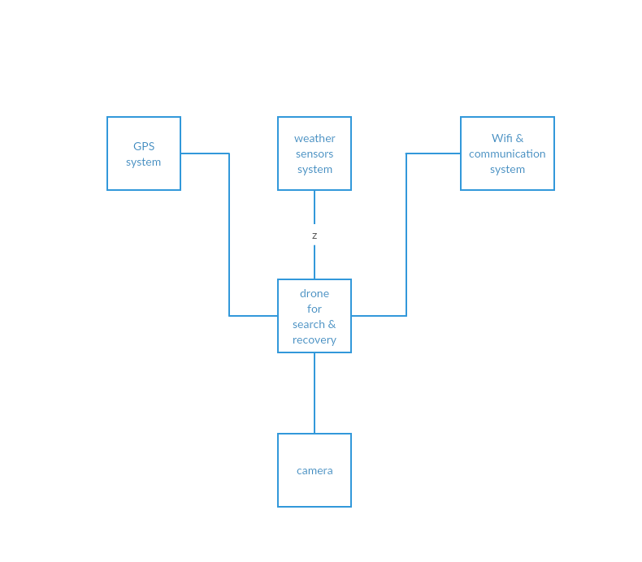

Figure4.1

## Use case model:

## 

Figure4.2

**Actors**: Ground operator, drone.

**Description**: This is main part of this project. Is how to dedicate an object using The SURF algorithm is used to identify the particular object and then the background will be subtracted to follow the identified object.

**Data**: Target information.

**Stimulus**: the color and the size of the target.

**Response**: Dedicated target, location, drone height.

**Comments**: The target info must match the object information it was matched with.

## Sequence diagram:

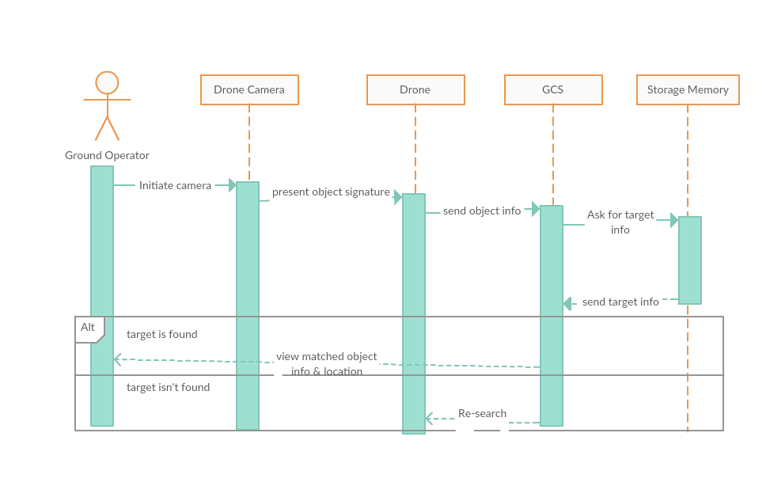

Figure4.3

# Flight Controller

## Use Case model:

Figure4.4

**Actors**: Pilot, Aircraft

**Description**: The pilot orders the craft by transferring commands via RX (transmitter & receiver) to calculate how fast each motor for spinning.

**Data**: Signals transmitted to aircraft

**Stimulus**: Pilot’s commands

**Response**: Confirmation of the commands.

**Comments**: The pilot must be the only one who has to control on the aircraft.

## Sequence diagram:

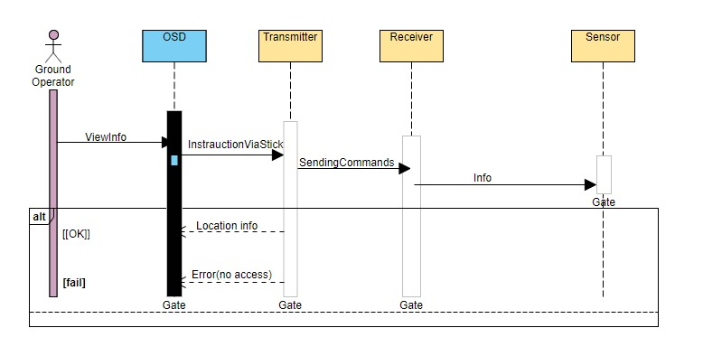

Figure4.5

## Activity model:

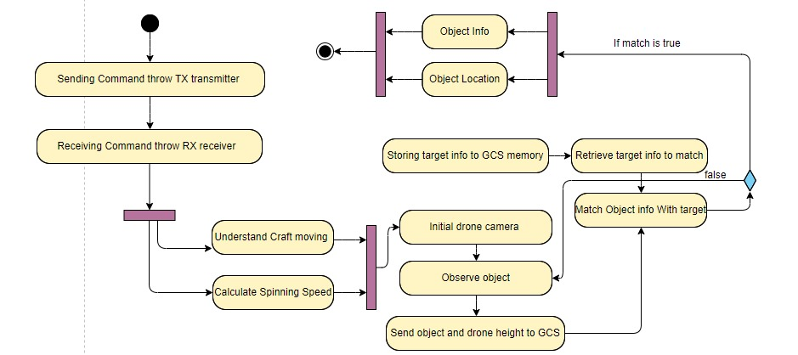

Figure4.6